3
Collaboration and the sharing of information are key to business success. Describe advantages of using a collaboration platform such as SharePoint to support business collaboration. Derive the information from your course materials and add a citation with just enough information to indicate the source; for example, (Module 1, Lecture...)
The answer is in Unit 6 (Read Communication and Connectivity)

Connectivity and Collaboration
Introduction
By 1980, stand-alone computers had gone mainstream, but word processing was still a mystery. Typists were just learning to cut and paste, having for decades painted over a typo with a white chemical. Hundreds of other features were slowly discovered by early adopters who were willing to learn and try. To a business owner, the costs seemed relatively fixed: the computer, the software, and a printer. But the costs quickly became evident. Employees pushed back. Processes changed. Hardware broke. Fixes were slow. Trainers with both hard and soft skills were rare. Nevertheless, the benefits of a stand-alone computer outweighed the challenges. The product of word processing or a spreadsheet application were tidy and calculations occurred quickly and accurately. Adoption of computers marched inexorably on.
Rather suddenly, organizations rewrote their budgets to support additional, recurring costs for computing that was so abstract that, even today, few can explain them. Not only were businesses buying machines for those at the top of the totem pole, and slowly for every employee, but also, despite the climbing explicit (dollars) and implicit (frustrated employees) costs, organizations were ready to spend more. Networks were born and began to proliferate. People were connecting and the Internet was quickly becoming an indispensable part of the business infrastructure.
In 1993, Time Magazine published the cover article “Take a Trip into the Future on the Electronic Superhighway” (Elmer-Dewitt & Jackson, David S., 1993). The title suggests a psychedelic experience; for many it was at least mystifying. The article jarred a society that had just begun to get intimate with their machines. The “information superhighway” would have a profound impact on society, the authors predicted, but not even they fully understood what they were writing about. The focus was largely on the future of television (recorded TV shows? Movies on demand!) and an Internet with which “families exchanged video Christmas cards…high school students shopped for a college by exploring each campus...or elementary schools made videos of the school play available to every parent who missed it” (Elmer-Dewitt & Jackson, David S., 1993). Referring to the Internet’s profit-making power, the authors pointed to decision-makers in entertainment and programming “eager to find out how much customers will shell out to see last night's [TV shows and explore] the market for addictive video games….” Entertainment value was a recurring theme. Wedged into that dense, multi-page 1993 narrative, in one brief phrase, a government official remarked that “[the Internet] is essential to a well-informed citizenry and electorate in a democracy” (Elmer-Dewitt & Jackson, David S., 1993). Oddly, the quote was couched in terms of TV-watchers. While the 1990’s were reveling in the novelty of astonishing graphics and instant communication, one already well-known computing expert shared his vision for the Internet. Bill Gates, co-founder of Microsoft, recognized twenty years ago and often spoke publicly about the Internet as “...an incredible opportunity to change the way business is done…” (Bill Gates Predicts the Future of the Internet, 1999).
Today’s use of the Internet is hardly quantifiable, as the numbers grow exponentially.
Internet Usage Worldwide as of November 30th 2017
World Regions | Population % of World | % of Internet Users | Global Internet Users % | Growth 2000-2017
Africa | 17% | 31% | 10% |  | 8503%
Asia | 55% | 47% | 50% |  | 1596%
Europe | 11% | 80% | 17% |  | 528%
Latin America / Caribbean | 9% | 62% | 10% |  | 2137%
Middle East | 3% | 59% | 4% |  | 4374%
North America | 5% | 88% | 8% |  | 196%
Oceania / Australia | 1% | 70% | 1% |  | 270%
In the beginning, designers learned HTML (hypertext markup language), the source code behind a Web page. HTML is not a programming language. It is a collection of shorthand symbols that indicate how text and images and other content should look on a page. Once completed to perform to the satisfaction of the developer, a Web page is published. Signals are picked up and passed to the next computer, through a server, and to the next and the next only if the vast amount of HTML (and variations of HTML) is composed expertly. Otherwise, one server would cause a display of helter-skelter content that is unreadable. In contrast to a “markup” language that essentially formats a Web page, developers using programming languages add logic to the mix and, with the correct logic, content becomes interactive. Naturally, ecommerce shaped the popularity of the Web among businesses. That’s easy to understand; but businesses were to continue to benefit from the Web in other ways too.
Storing data and information in the cloud, for example, was slow to catch on at the turn of the century. The idea of saving a file on a machine that is nowhere to be seen is still too abstract for many. Businesses, however, began to see the advantages. Once bogged down by the management of complicated in-house email, file, and application servers, many businesses have given over to public cloud service providers like Microsoft’s Azure and Amazon Web Services. While cloud services didn’t catch on until the second decade of the twenty-first century largely due to cost and complexity, the human brain, seemed to crave connectivity. The effects of sharing information became more than a curiosity for businesses. Social networking was quickly recognized as a valuable marketing tool, for example, and the potential to support collaboration among colleagues became evident. But applications specifically designed to support colleague collaboration was (and still is) slow to be accepted. After all, businesses have historically been a “star-driven culture,” as Harvard’s Heidi Gardner characterizes the resistance to collaboration; losing control is a factor and humans take pleasure in being a resident expert (Gardner, 2017). So why collaborate?
... engaging in smart collaboration…is about producing results, not just playing nicely together in the sandbox (though that’s also important). By pooling their know-how and resources across boundaries, organizations can solve problems more creatively, increase their productivity, and reap higher profits—achievements that attract top-caliber talent and keep the stars engaged… In surveys of thousands of employees worldwide… [appreciate] the camaraderie of collaboration, the intellectual challenge associated with more complex work, and the ability to learn from others can be crucial motivators. (Gardner, 2017).
Technology obviously enters into this picture. In the early 2000’s collaboration platforms started taking shape but were misunderstood or simply rejected. Communication channels had already been unified—voicemail could be read in email messages, meetings organized on chat apps, videoconferences with large numbers of participants—what more could a collaborative culture need to flourish? As research emerged on the value of collaboration more interest in a supporting infrastructure began to evolve. Microsoft’s SharePoint was one of the first platforms to be released. The year was 2001.
Here’s a simple example of a SharePoint app: Imagine a meeting with ten employees in attendance. One of the employees is taking meeting notes on a tablet. Typically, the file is then attached to an email to everyone in attendance including the note-taker. The meeting participants each have their own copy. They are asked by the meeting host—let’s say the CEO—to read the notes and make corrections in case the note-taker misunderstood or made an error of some kind. Each meeting participant does so, crossing out an incorrect statement and putting comments in the margins. Nine participants return the minutes to the note-taker, who compiles all the corrections onto his or her copy of the notes. Now the note-taker has ten different files. She or he notices right away that two meeting participants have made contradictory corrections to the same paragraph. As the note-taker peruses the rest of the files, suggested changes abound with no consensus. This is a very realistic scenario that occurs when the same file is shared with many people through an email attachment. In other words, no one is, literally, on the same page. Businesses that have a collaboration platform, like Microsoft SharePoint, streamline the above process by using a SharePoint “document library” app. Instead of attaching the meeting minutes to an email to those meeting attendees, the note-taker finds the option on the SharePoint website’s homepage to create the library app. The note-taker has no knowledge or HTML—the formatting code mentioned above—or programming. A couple of clicks later, the note-taker is creating folders in the library. She or he wants to keep meeting notes from several years back and several years in the future, so a folder is created for each of the previous five years, the current year, and a few future years. Each annual folder might contain more folders. In a few steps, files have a resting place that is very organized. With no technical background, the note-taker proceeds, creating twelve more folders: January, February, March, April, and so on, inside every annual folder. In this scenario, the note-taker has created a storage structure in a few minutes. A meeting ends, the note-taker looks over the notes and uploads them into the appropriate folder. Instead of each meeting participant reviewing their own copy, they are directed to click on a URL that brings them to only one file. Meeting participants are on the same page. They can edit simultaneously. If they happen to be reviewing the same paragraph at the same time, SharePoint will alert them both by adding a dotted line at the paragraph in which Mr. X or Ms. Y is currently editing. When Mr. X has completed his edits, Ms. Y will see the corrections in a different color font. After several minutes, the color of the text reverts to its original font. Their collaboration is supported by the SharePoint platform.
A business needs much more than high-powered file sharing and simultaneous editing. Consider the usefulness of a newsfeed to watch stock prices; a tracking system to mark milestones of a project; a list with the names and contact information of suppliers; a wiki (Web page) to which all can exchange ideas.
The needs of a business and the app on a given SharePoint site depend on the functional area of a business, such as the payroll department or the human resources department, or the objectives of the position on the organization’s hierarchy, such as the CEO, a manager, or an administrative assistant. An average worker builds the apps the business work group needs—the newsfeeds, project tracking, or records keeping mentioned above.
Like all Microsoft products, SharePoint apps use interfaces and functionality that overlap with other Microsoft products, like Excel. For example, let’s say that you’ve started a dog-walking business. In SharePoint, you can create a “custom list” that will automatically calculate certain fields, such as price per hour multiplied by hourly fee, with an added fee of ten percent for dogs weighing over fifty pounds. In Microsoft Excel, you would create something like this:
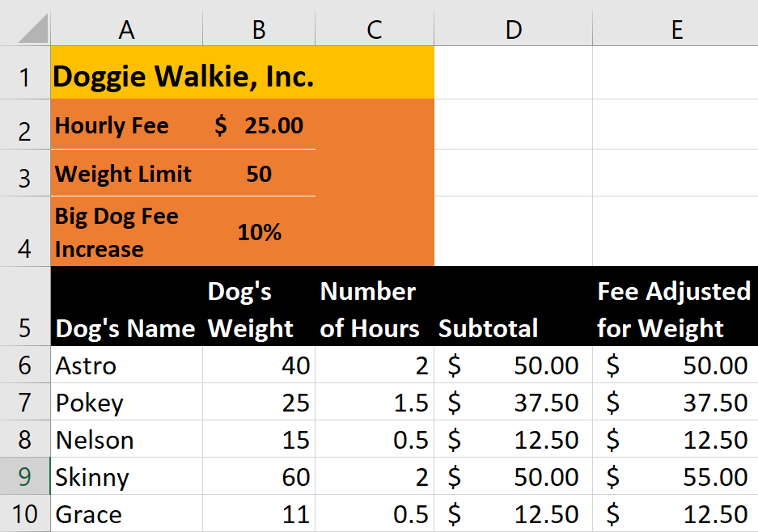
The simple spreadsheet above has eight fields and two formulas. The eight fields are
- Hourly Fee
- Weight Limit
- Big Dog Fee Increase
- Dog’s Name
- Dog’s Weight
- Number of Hours
- Subtotal
- Fee Adjusted for Weight

The logic behind the formulas is the same in any app that needs a calculation.
A SharePoint app has advantages over Excel. First, the formula uses field names (such as “Number of Hours”) rather than cell references (such as “B6”), which are selected from the list of fields, hence the formula is more descriptive (for example, “Number of Hours * Hourly Fee”). The formula in SharePoint doesn’t require a distinction between relative and absolute references because the value for “Hourly Fee”—in this case, $25-- is set as the default for that field; every new record is populated with the hourly rate automatically. A SharePoint list requires only a browser, so users don’t need to worry about whether they have a compatible version of Excel; the browser-based SharePoint app produces a link that is easily shared; and the items in a list can be synced with other lists in SharePoint.
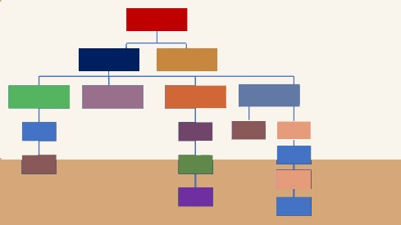
SharePoint Structure
In summary, SharePoint is a collection of Web pages with easily created apps. Figure 1 illustrates a simple SharePoint structure that applies to any website. At the top level (the red rectangle) is the home page of, let’s say, a marketing department. A home page typically has a vertical link bar (called a “quick launch bar”) for access to any apps within the marketing department. A horizontal set of links (called “global” links) serves to link other home pages (for example, payroll, human resources, manufacturing, sales, etc.). What does the marketing department’s SharePoint home page need? Perhaps a banner identifying MARKETING DEPARTMENT, a welcome message, a staff meeting calendar, and a slide show. The top level (i.e., home page) is linked to two “subsites.” One subsite, let’s say, is called “Art” and the other site is called “Text” (marketing experts will forgive the over-simplification). The Art subsite may have a slide show of the artwork for the current project; the Text subsite is organized with document libraries, lists, and feeds. Both subsites have a project calendar that is connected. If you look closely at Figure 1, two subsites link to four subsites: art that is created in-house, art that is purchased, copyright resources, and archives. Three of the four subsites have subsites of their own.
Figure 1 SharePoint Structure
Subsites are based on templates that Microsoft has already prepared for businesses specifically, guessing what sort of activities a group of workers may need.
Subsites proliferate, and if a site isn’t planned carefully in advance it will eventually turn into a pile of disorganized information. The SharePoint site in a business needs to be drawn out ahead of time with the input of all stakeholders, starting at the top with the CEO, then high-, mid-, and low-level managers, and all other workers in department or workgroup. Pages, libraries, calendars, etc., can be added without special skills, such as programming in an unfamiliar and complicated language. And most importantly, every page or app is shared by individuals who need to collaborate, and groups that need to collaborate with other groups.
SharePoint sites structured in this way are admittedly difficult to manage. Each subsite is its own entity and moving apps or integrating subsites is cumbersome. Microsoft’s 2018 improvements include the use of “hub sites.” Hub sites aggregate information across the board, from various subsites. The interface of a hub site is especially useful in this version of SharePoint, as it includes thumbnail images of integrated sites. SharePoint’s already powerful search functionality is more useful as, from a hub site, it can search across all subsites, which otherwise would be isolated entities. Hub sites are created by SharePoint administrators (not the average user) and users with the right permissions may join their sites (often referred to as “team sites”) to the hub. If a business restructures itself in real life, hub sites make it easy to restructure the entire SharePoint website.
As already mentioned, SharePoint is a collection of Web pages with easily created apps. It is composed of a home page or a hub site and team sites (remember, team sites and subsites are the same). It also has “communications” sites, which, like team sites, have out-of-the box apps that average users can customize. The functionality of team sites and communications sites overlap, but communication sites are more like a billboard that displays information for a wide audience. Team sites have more features that support collaboration. Under all circumstances, the foundation of a SharePoint site is developed by sophisticated programmers to allow end users to customize according to their own needs.
Who Manages a SharePoint Site?
The SharePoint developer in a business is usually not someone at the top of the totem pole. More likely it is a lower management employee or an administrative assistant who becomes a “power user” as she or he becomes familiar with the platform. Today, SharePoint power users are almost indispensable. Every group of employees who collaborate will have a highly customized site, yet not everyone in an organization will need to know how to build, for example, a picture slide show. Power users usually emerge from the crowd. These are staff members who enjoy computing, are extremely well-organized, and have great communication skills. A business is better off using these individuals to centralize certain training and design support for everyone. Why? Because SharePoint websites are so easy to develop that everyone wants to add their own app. Without at least some oversite, duplications occur, team sites pop up in the wrong place, and navigation becomes untenable. For these reasons, permissions should be strictly handled by a limited number of power users.
To clarify the idea of “permissions,” think in terms of “who should have access to what.” A shipping manager should not have access to payroll information. A marketing employee doesn’t need to have access to the shipping department’s team site, and so on.
Permissions can be confusing if the structure of a SharePoint site is disorganized. Essentially, however, permissions can be characterized by “inheritance” and “disinheritance” and by roles such as “owners,” “contributors,” or “visitors.” Inheritance means that a subsite will have the same permissions as its “parent.” If the parent site has payroll information on it, and a subsite is for payroll staff party planning, the two sites can be separated (disinherited) so that the party planners don’t get too much information on payroll. The schema cascades to the lowest levels on a SharePoint hierarchy. In other words, a single file in a folder in a library on a team site can have its own unique permissions.
Every site has an owner. The owner has the broadest permissions. She or he can do anything—create apps, delete information, etc. Other roles have various permutations of what a user can and can’t do. “Visitors” can read only; they can’t add, move, or modify anything. “Contributors” can edit Word files, for example but can’t delete applications.
Special Features
Web Parts. How is a team site designed? Usually, a SharePoint power user who has a sense of what is most important to a group decides what the home page of a team site looks like and how it is navigated. For example, the home page of a department probably displays a meetings calendar, a well-organized library with evidence of assessments, another library for files to go into board reports, and a newsfeed that presents headlines from major trade publications. The things that are actually displayed on the page is a web part. Other applications that may not be used on a daily basis, such as a specific list of upcoming projects, aren’t displayed; they are linked.
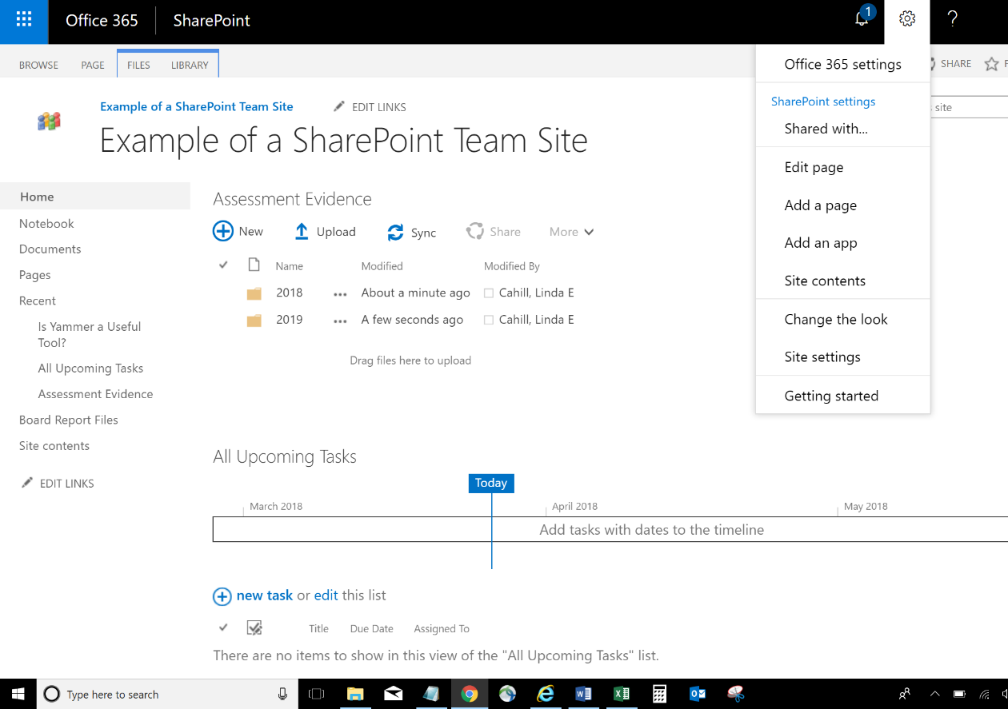
Notice in the image above that the power user who is overseeing this team site has decide to display “Assessment Evidence” (a library) and “All Upcoming Tasks” front and center, so that when a staff member enters the team site this is the first thing he or she sees. Plenty of other apps have been created, but to display an app, a user inserts a Web Part onto the page.
One of the Web Parts that is displayed in the image above is a library created and designed with folders created by a staff member. Web Parts are also apps that SharePoint provides out of the box. For example, Tasks, Blogs, Filters, and Social Collaboration. SharePoint apps can also be purchased from third-party vendors; for example, an app that generates usage metrics (statistics to measure something) on specific activity.
Workflows. Workflows are a special feature that take an extra bit of logic. Using the dog walking business mentioned earlier in this article, a list can be customized with a yes-no field for payments that have been received and fields for “Date Paid,” and “Payment Overdue.” When the status of any payment becomes overdue, SharePoint can be configured to automatically generate an email to alert the business’s accountant. The email has customized content and “string substitution” functionality. Once the workflow is activated, it will forever fire off an email to the business’s accountant for any overdue payments without a human initiating the action.
The owners of [Dog’s Name] are overdue in their payment of [Fee Adjusted for Weight]. Contact the owner at [Owner’s Email].
When Doggie Walkie’s accountant receives an email as an alert that a customer is overdue, “Astro” is substituted for [Dog’s Name], “$50.00” is substituted for [Fee Adjusted for Weight], and the dog owner’s actual email address is substituted for [Owner’s Email]. Underlying workflows are relational databases.
The business’s developer configures the workflow with simple logic: send an alert to accounting@doggiewalkies.com when the purchase date plus thirty arrives. It looks and sounds like programming, yet the business’s SharePoint developer is not a programmer. Sharepoint apps provide no-code development to average employees who rediscover their intuitive ability to use logic.
As the business grows, workflows proliferate. A customer pays for services with a check. The dog walker initiates a workflow that asks for approvals in a sequence. The message “Can we accept a check from [Dog Owner’s Name] at [Dog Owner’s Email]?” with an image of the check and string substitution for the name and email of the dog owner. The message is set up to go to the operations manager, then the accountant, and then the CEO, in exactly that order. If the operations manager approves (a one-click process), the message is routed to the accountant, if the accountant approves, the message is routed to the CEO. If anyone in that chain of command rejects checks as a form of payment, the message goes no further. The CEO, who has better things to do, never sees the question if the operations manager or accountant makes a decision to reject payment by check.
There are many other types of workflows, including a workflow that collects digital signatures and customized workflows that operate under specific circumstances only. For example, the business manager modifies the list by adding a yes-no field called “Bath.” If the administrative assistant gets a call from a customer who would like little Nelson to get a bath after his walk, a workflow could be constructed so that, after the administrative assistant marks “Bath” as “Yes” on, say, Thursdays, SharePoint will assign a task to a specific employee who will confirm the task and update it when the task is completed; the workflow will then proceed to update the balance due with no human intervention.
Hybrid Search. SharePoint can be hosted (the place where the software resides) on business premises, in the cloud, or both. Many organizations opt for both to retain control over some functionality. A very useful special feature of SharePoint is the hybrid search, which allows users to search servers in-house or in the cloud.
Durable Links. When you save a document on a Web-based platform, its location is reflected in the path. The path, otherwise known as the URL, may look something like this:
https://sharepoint.countertops.com/importantlibrary/2018/very-important-file.docx
At the end of the path, is a “very-important-file.” Reading the path from right to left, notice that the “very-important-file” is inside a “2018” folder, which is inside an “important-library” on the company (called “countertops”) SharePoint site.
SharePoint provides “durable links,” which are sometimes referred to as “self-adjusting” links. For example, suppose you move your “very-important-file” to a new library called “archives.” Wouldn’t the path change? And if it does change, what happens when a colleague clicks on it? The message that everyone hates appears: “This page cannot be found” (or some variation). In SharePoint, the link will adjust itself. Such a feature has become somewhat less of a novelty for Web links, but renaming a file is still a disruption for many website developers. Not for SharePoint. A renamed file is automatically renamed in the path that brings the user to the file’s location.
Yammer. Yammer is a SharePoint Web Part that connects users based on topics rather across team sites. It has the same features as many other social networking platforms, but it is also specifically designed for colleague collaboration. SharePoint users can join groups, get feedback through polls, and prioritize messages.
The above are popular features, but are only a fraction of what SharePoint can do. The reader may infer that SharePoint is an easy-to-use platform, and it is, but not before users overcome their affective barriers: it can be intimidating to face a new look and feel compared with applications commonly used for decades. SharePoint takes a bit of training, just like email and Word once required.
As Bill Gates once characterized the Internet as a “gateway to knowledge” (Gates, 2000) so does SharePoint break down barriers in organizations whose individuals and functional units once operated in silos. Today, using a collaboration platform is a channel through which the individual heroism of a niche expert gives way to a culture of working together to make organizations more productive, more creative, and more profitable.

Bibliography
Anderson, M. (2017, December 28). Key Trends Shaping Technology in 2017. Retrieved from Pew Research Center: http://www.pewresearch.org/fact-tank/2017/12/28/key-trends-shaping-technology-in-2017/
Bill Gates Predicts the Future of the Internet (1999). [Motion Picture]. London School of Economics. Retrieved March 7, 2018, from https://www.youtube.com/watch?v=2lZasDD2DvY
Elmer-Dewitt, P., & Jackson, David S. (1993, April 12). Take a trip into the future on the electronic superhighway. Time Magazine, 141(15), p. 6.
Gardner, H. (2017, January-February). Harvard Business Review.
Gates, B. (2000, December 1). Shapting the Internet Age. Retrieved from Microsoft: https://news.microsoft.com/2000/12/01/shaping-the-internet-age/
Google - Statistics and Facts. (2017). Retrieved from Statistica: https://www.statista.com/topics/1001/google/
Kashman, M. (2017, October 19). SharePoint Hub Site Overview. Retrieved from Microsoft: https://www.youtube.com/watch?v=eFbJxW3XA7I
Langlois, S. (2017, July 26). What’s New in SharePoint 2016. Retrieved from SherWeb: https://www.sherweb.com/blog/sharepoint-2016/
Noyes, D. (2018, February 1). The Top 20 Valuable Facebook Statistics – Updated February 2018. Retrieved from Zephoria: https://zephoria.com/top-15-valuable-facebook-statistics/
Usage and Population Statistics. (2017, November). Retrieved from Internet World Stats: http://www.internetworldstats.com/stats.htm

Technical skills are often referred to as “hard skills” and effective communication are often referred to as “soft skills.”
Bill Gates founded Microsoft with Paul Allen
Demographic (Population) numbers are based on data from the United Nations Population Division. Internet usage information comes from data published by Nielsen Online, by ITU, the International Telecommunications Union, by GfK, by local ICT Regulators and other reliable sources.
The first formula is typed in D5 as =C5*B2 and copied into all rows of column D (with the absolute reference to B$2 so that B2 doesn’t change to B3, B4, B5, etc., when you copy it). The second formula does the same thing, but the fee increases if the dog weighs over 50 pounds. The formula is typed in E5. It multiplies the number of hours by the hourly fee; then it checks the weight of the pooch and adjusts the total: =IF(B6<B$3,C6*B$2,D6+(D6*B$4))*
Special features may not be available in SharePoint versions 2013 and older.
“Silos” is a term used for a business culture in which functional areas and individuals fail to share their resources with others.
The image of the cell phone is by Redrum0486 (http://en.wikipedia.org/wiki/File:DynaTAC8000X.jpg) [CC BY-SA 3.0 (https://creativecommons.org/licenses/by-sa/3.0) or GFDL (http://www.gnu.org/copyleft/fdl.html)], via Wikimedia Commons

